Bias Beyond Magnitude: Regression Diagnostics for Functional Approximations
Thomas Subia (Danville CA)
Statistician
Email: tgs77m@yahoo.com

Thomas Subia holds a Bachelor of Science in Statistics from California State University, Hayward. He has worked as a statistician and quality engineer at Lawrence Livermore National Laboratory, Northrop Grumman, and Lam Research. His professional interests include applying statistical and quality-engineering methods to improve processes and exploring novel ways to make analytical concepts accessible and intuitive in educational contexts.

Bias Beyond Magnitude: Regression Diagnostics for Functional Approximations

Abstract
Relative error is the conventional metric for evaluating approximation accuracy, but it collapses directional information into magnitude and therefore cannot reveal systematic bias. This paper highlights the pedagogical value of bias diagnostics as a complementary tool for teaching approximation methods. Using the 4th-order Generalized Binomial Expansion of $h(x)=(x^{2}-2x)^{0.9}$for $x>2$, bias is defined as the signed difference between approximation and exact value. Sampling across the domain $\left[40 , 240\right]$, regression analysis of bias versus $x$reveals a small but statistically significant underestimation trend that contracts asymptotically, confirming convergence of the expansion. Unlike relative error, bias analysis narrates behavior: it shows whether approximations lean systematically high or low, and how that lean evolves across the domain. Because regression diagnostics are simple, interpretable, and visually compelling, they provide an accessible framework for students and practitioners to understand approximation quality beyond pointwise accuracy.
Keywords: Bias analysis, Relative Error, Functional Approximation, Generalized Binomial Expansion, Regression Diagnostics. Systematic Bias, Asymptotic Convergence, Pedagogical Accessibility, Signed Error, Approximation Error

Let $h(x)= {( x^{2}-2x )}^{0.9}$

For x > 2, we approximate h(x) with a 4th order Generalized Binomial Expansion

$h\left(x\right) ≈ x^{1.8}+1.8 x^{0.8}$ – 0.18 $x^{-0.2}+0.132 x^{-1.2}$ – 0.1386 $x^{-2.2}$

For a given x in the domain x > 2, we can calculate the bias using:

$$Bias =Approximation-True Value$$

Relative error quantifies magnitude of deviation but does not preserve directional information and therefore cannot diagnose systematic bias or trend behavior across a domain.

While relative error is widely used to assess approximation accuracy, it is less commonly employed as a diagnostic for systematic behavior across a domain. This article argues that bias analysis, summarized through simple regression diagnostics, provides a complementary and pedagogically accessible tool for evaluating functional approximations.

Stepwise mechanism.
Although the approximation error is deterministic, linear regression is used here as a diagnostic summary tool, enabling global quantification of bias magnitude and trend across the domain rather than local pointwise inspection
- Define exact and approximate functions
  - Exact: $g(x)=(x^{2}-2x)^{0.9}$
  - Approx: $a(x)=x^{1.8}+1.8x^{0.8}-0.18x^{-0.2}+0.132x^{-1.2}-0.1386x^{-2.2}$
- Bias function
$$\text{Bias}(x)=a(x)-g(x)$$
- Sampling domain
  - Draw 100 random $x$values uniformly from $\left[40 , 240\right]$.
  - Compute bias for each.
  - Random subsampling is used solely to avoid visually and numerically over-weighting dense regions of the domain; results are stable under resampling due to the deterministic nature of the approximation.
- Global statistical measure
  - Fit regression: $\text{Bias}(x)∼x$.
  - Extract slope, SE, and p-value.
  - If slope ≈ 0 and p-value > 0.05 → approximation unbiased across domain.
  - If slope ≠ 0 but small magnitude → approximation has systematic trend but remains close.

Statistical Analysis
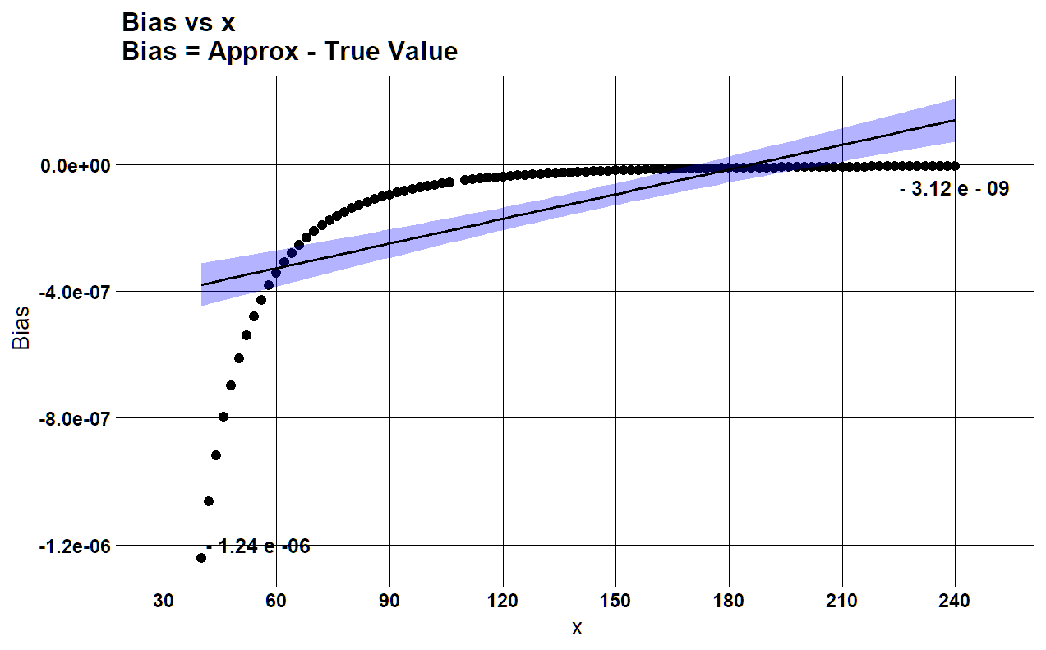
Figure 1 Bias vs. x with regression overlay. Bias is defined as the signed difference between the 4th-order Generalized Binomial Expansion and the exact value $g(x)=(x^{2}+2x)^{0.9}$. The regression line reveals a small systematic underestimation whose magnitude contracts and flattens as $x$increases, consistent with asymptotic convergence of the expansion. Annotated values at $x=50$and $x=240$highlight the tightening bias, shrinking from $-1.24×{10}^{-6}$ to $-3.12×{10}^{-9}$, confirming asymptotic accuracy across the domain.
Results.
A linear regression of bias versus $x$confirms a a small but clearly detectable increasing trend. The estimated slope is $2.600×{10}^{-9}$with a p-value of $3.37×{10}^{-14}$, indicating a small but measurable bias trend that diminishes in relative importance as x increases. The estimated average bias is also $2.600×{10}^{-9}$, effectively confirming that the approximation converges toward the true value as $x$increases. Together, these results validate the sufficiency of the 4th-order Generalized Binomial Expansion across the domain $\left[40 , 240\right]$.
Importantly, the analysis demonstrates that the Relative Error metric cannot identify the magnitude of the bias between the GBE approximation and its associated true value. Practitioners are therefore encouraged to adopt linear regression diagnostics as a practical tool for quantifying the magnitude and trend of functional approximations.
Relative error establishes accuracy; bias analysis establishes behavior. Together, they provide a complete diagnostic picture of functional approximation quality.

R Script: Bias differences for [40,240] x domain
exact <- function(x) (x^2 + 2*x)^0.9
approx <- function(x) x^1.8 +
1.8000 * x^0.8 -
0.1800 * x^-0.2 +
0.1320 * x^-1.2 -
0.1386 * x^-2.2

xs <- seq(40,240,2)
# domain of xs $\left[40 , 240\right]$.

diffs <- approx(xs) - exact(xs)

sample_data <- data.frame(xs,diffs,approx(xs),exact(xs))

# Get random data of size 100 from sample data
set.seed(123)
idx <- sample(seq_len(nrow(sample_data)), size = 100, replace = FALSE)
sample_diffs <- sample_data[idx, ]

R Script: Regression Model

# Perform linear reression on diffs and xs
fit <- lm(sample_diffs$diffs~sample_diffs$xs)

summary(fit)
Summary Fit ANOVA Table
ANOVA Regression Table:
lm(formula = sample_diffs$diffs ~ sample_diffs$xs)
Residuals:
Min 1Q Median 3Q Max
-8.633e-07 -6.605e-08 3.709e-08 1.199e-07 1.560e-07
Coefficients:
Estimate Std. Error t value Pr(>|t|)
(Intercept) -4.825e-07 4.454e-08 -10.831 < 2e-16 ***
sample_diffs$xs 2.600e-09 2.930e-10 8.873 3.37e-14 ***
---
Signif. codes: 0 ‘***’ 0.001 ‘**’ 0.01 ‘*’ 0.05 ‘.’ 0.1 ‘ ’ 1
Residual standard error: 1.714e-07 on 98 degrees of freedom
Multiple R-squared: 0.4455, Adjusted R-squared: 0.4398
F-statistic: 78.73 on 1 and 98 DF, p-value: 3.373e-14
R Script: Graph

library(ggplot2)
library(cowplot)

plot <- ggplot(sample_diffs,aes(x=xs,y=diffs)) +
geom_point(shape = 21, fill = "black", size = 3)

plot + stat_smooth(method=lm,fill="blue",alpha=0.3,
color="black")+theme_minimal_grid(font_size = 16,color="black")+
ggtitle("Bias vs x\nBias = Approx - True Value")+
scale_x_continuous(limits=c(30,250),breaks=seq(30,240,30)) +
ylab("Bias") +
xlab("x") +

theme(
axis.text.x = element_text(face = "bold"),
axis.text.y = element_text(face = "bold")) +
annotate("text", x = 55,
y = -1.2e-6, label = "- 1.24 e -06",fontface="bold",
size=5) +
annotate("text", x = 240,
y = -7e-08, label = "- 3.12 e - 09",fontface="bold",
size=5)

